**C++**

**OOP concept**

The object-oriented programming is a different approach to programming. It has been created with a view to increase programmer’s productivity by overcoming the weaknesses found in procedural programming approach.

**Principles of OOP**

There are mainly four OOP Principles

* Abstraction
* Encapsulation
* Inheritance
* Polymorphism

**Example: Calculator**

**Private and Public**

**Private:**

Private members of the class can be accessed within the class and from member functions of the class.

• They cannot be accessed outside the class or from other programs, not even from inherited class.

• If you try to access private data from outside of the class, compiler throws error.

**Public:**

* The public keyword makes data and functions public.

• Public members of the class are accessible by any program from anywhere.

**Example**

**Function Definition Outside Class**

**Passing Objects as Function Arguments**

**Returning Objects from a Function**

**Friend Function**

**Code:**

**Static Data members**

* Data members of the class which are shared by all objects are known as static data members.
* Only one copy of a static variable is maintained by the class and it is common for all objects.
* Static members are declared inside the class and defined outside the class.
* It is initialized to zero when the first object of its class is created.

**Program : Static data member**

**Constructors**

**Code:**

**Types of Constructors**

* Default constructor
* Parameterized constructor
* Copy constructor

**Code: default**

**Para constructor**

**Function**

**Inline**

**Function Overloading**

**Code: Function overloading**

**Code: operator overloading**

**Code: operator to class overloading**

**Inheritance**

**Types of Inheritance**

1. Single Inheritance

2. Multilevel Inheritance

3. Multiple Inheritance

4. Hierarchical Inheritance

5. Hybrid Inheritance (also known as Virtual Inheritance)

**Code:**

**Code:**

**Code:**

**Code:**

**Code:**

**Polymorphism**

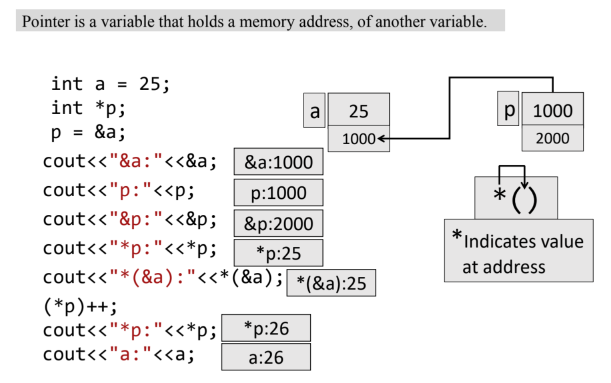

**Pointer to derived class**

* We can access those members of derived class which are inherited from base class by base class pointer.
* But we cannot access original member of derived class which are not inherited from base class using base class pointer.

**Code:**

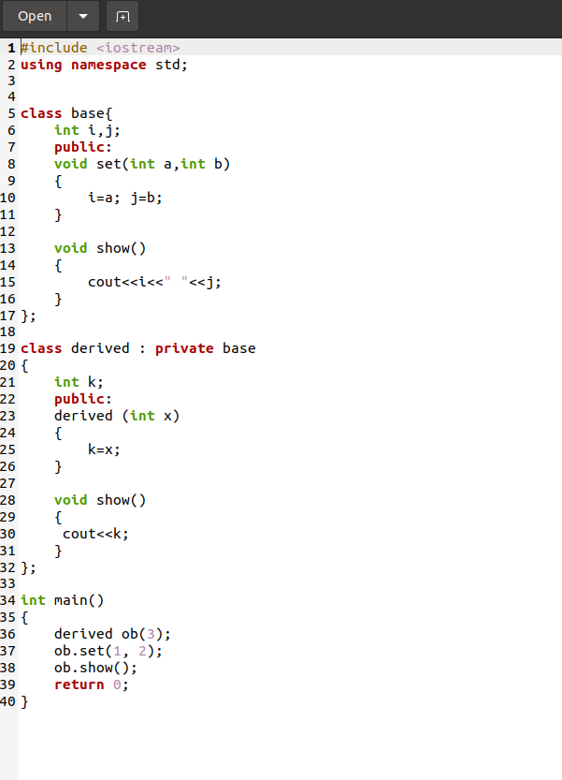

**Code:**

**Code:**

**Virtual Function**

* A virtual function is a member function that is declared within a base class and redefined by a derived class.
* To create a virtual function, precede the function's declaration in the base class with the keyword virtual.

**Code:**

**Abstract Class**

* A class that contains at least one pure virtual function is called abstract class.
* You can not create objects of an abstract class, you can create pointers and references to an abstract class.

**I/O and file handling**

**Code:**

**Functions for file pointer manipulation**

**Templates**

* It allows functions or class to work on more than one data type at once, without writing different codes for different data types.
* Templates are often used in larger programs for the purpose of code reusability and flexibility of program

**Types of Templates**

* Function templates
* Class templates
* Variable templates

**Code:**

**Code:**

**Code:**

**Graphs**

* A graph is a non-linear data structure. A graph can be defined as a collection of Nodes which are also called “vertices” and “edges” that connect two or more vertices
* A graph can also be seen as a cyclic tree where vertices do not have a parent-child relationship but maintain a complex relationship among them.

**Types of Graphs**

* Direction
* Directed
* Un-directed

